**CEBU INSTITUTE OF TECHNOLOGY**

**UNIVERSITY**

**COLLEGE OF COMPUTER STUDIES**

Software Design Description

for

Earthquake Analyzer

Signature

*_________________________*

***Marvin Joshua P. Chewchut*** *Team Leader  
Project Analysis*

*_________________________*

***Keith Joseph B. Damandaman*** *Data Analysis  
Programmer*

*_________________________*

***Clark Jay R. Cortezano*** *Lead Programmer  
Program Designer*

Change History

|  |  |  |  |
| --- | --- | --- | --- |
| Revision no. | Changes | By | Date |
| 1.0 | Added Title  Added Purpose  Added Scope  Added System overview | Keith Joseph Damandaman | September 13, 2018 |
| 1.1 | Added Signature  Added Change History  Added Screen Images  Added Screen Objects and Actions  Added Preface | Keith Joseph Damandaman | October 12, 2018 |
| 1.2 | Added System Architecture  Added Data Design  Added Component Design  Added System Overview | Marvin Joshua Chewchut | October 15,2018 |
| 1.3 | Finalizing document | Keith Joseph Damandaman | October 15, 2018 |
| 1.4 | Revision on System Overview  Revision on System Architecture | Marvin Joshua Chewchut | October 16, 2018 |

Preface

Earthquakes are one of the most dangerous natural disaster on Earth especially to the infrastructures. It would be nice if we could monitor the seismic behavior of the earth’s crust when there is an earthquake. Today, we have the technology to do make that with come true. Unfortunately, here in the Philippines, we still have to import this technology to the country and the price of this technology is nothing to laugh at. This is where the Earthquake analyzer comes into play.

Table of Contents

Contents

Signature 2

Change History 3

Preface 4

Table of Contents 5

List of Figures 6

List of Tables 7

1. Introduction 8

1.1. Purpose 8

1.2. Scope 8

1.3. Reference Material 8

1.4 Definitions and Acronyms 8

2. System Overview 9

3. System Architecture 10

3.1. Architectural Design 10

3.2. Decomposition Description 11

3.2.1. Use Case Diagrams 11

3.2.2. Use Case Diagram Scenarios 12

3.2.3. Class Diagram 13

3.3. Design Rationale 15

4. Data Design 16

4.1. Data Description 16

4.2. Data Dictionary 16

5. Component Design 17

5.1. Sequence Diagrams 17

5.2. Overview of User Interface 22

6. Human Interface Design 23

6.1. Screen Images 23

6.2. Screen Objects and Actions 25

7. Requirement Matrix 29

8. Appendices 30

List of Figures

|  |  |  |
| --- | --- | --- |
| Figure no. | Name of Figure | Page |
| 3.1.1 | System Architecture | 10 |
| 3.1.2 | System Architecture Views | 10 |
| 3.2.1.1 | Drop Down Module | 11 |
| 3.2.1.2 | Real Time Module | 11 |
| 3.2.1.3 | Load Data Module | 12 |
| 3.2.1.4 | Compass Module | 12 |
| 3.2.3.1 | Drop Down Class Diagram | 13 |
| 3.2.3.2 | Real Time Class Diagram | 14 |
| 3.2.3.3 | Load Data Class Diagram | 14 |
| 3.2.3.4 | Compass Class Diagram | 15 |
| 4.1.1 | Earthquake Data Class | 16 |
| 5.1.1 | Drop Down Sequence Diagram | 17 |
| 5.1.2 | Compass Sequence Diagram | 17 |
| 5.1.3 | Load Data Sequence Diagram | 18 |
| 5.1.4 | Real Time Class Diagram – Initialization | 18 |
| 5.1.5 | Real Time Sequence Diagram – Continuation of Initialization | 20 |
| 5.1.6 | Real Time Sequence Diagram – Smooth Thread | 20 |
| 5.1.7 | Real Time Sequence Diagram – Line Chart Update and Earthquake Detection | 21 |
| 5.1.8 | Real Time Sequence Diagram – Compass Animation | 21 |
| 5.1.9 | Real Time Sequence Diagram – Restart Button | 22 |
| 5.1.10 | Real Time Sequence Diagram – Record Button | 22 |
| 5.1.11 | Real Time Sequence Diagram – Save Data Button | 22 |
| 6.1.1 | Earthquake Analyzer Orientation screen | 24 |
| 6.1.2 | Drop Down Menu screen | 24 |
| 6.1.3a | Real time page pop up message | 25 |
| 6.1.3b | Real time screen | 25 |
| 6.1.4a | Load data screen | 25 |
| 6.1.4b | Shown data screen | 25 |
| 6.1.5a | Select data screen | 26 |
| 6.1.5b | Data selected | 26 |
| 6.2.1 | Drop Down Button | 26 |
| 6.2.2 | Drop Down Menu Buttons | 27 |
| 6.2.3 | Real Time Pop up Message | 27 |
| 6.2.4 | Real Time Screen Objects | 27 |
| 6.2.5 | Load Button | 28 |

List of Tables

# Introduction

## Purpose

This Software Design document provides the design description of the system Earthquake analyzer. It will describe how the system will be constructed and implemented. This document is aimed to translate software requirements defined in SRS document into a representation of software components, interfaces and data to be used later in implementation phase of the project. The main target audience of this project is the Department of Science and Technology - Philippine Institute of Volcanology and Seismology (DOST-PHILVOLCS) and Engr. Ralph Laviste. This document will also serve as a reference for the software side of the Design Project of the makers.

## Scope

This complete SDD contains the full description of how the Earthquake Analyzer application will be constructed. In analyzing the hypocenter of an earthquake using an accelerometer, the P wave must be found first, then the S wave, the difference of the P wave and S wave will be then multiplied by 8 and that will be the hypocenter. To find the general direction of where the earthquake is, using the device as the reference origin, the maximum amplitude of X and Y axis of the P wave must be analyzed. The application will use the accelerometer of an android phone as its sensor, and the readings will be displayed on the screen. The user can choose to view past readings to view, or choose the real time reading.

## Reference Material

<https://en.wikipedia.org/wiki/Comma-separated_values>

## 1.4 Definitions and Acronyms

SRS Software Requirement Specifications   
SDD Software Design Document   
UML Unified Modeling Language

# System Overview

The software has three main mode: real time mode, load data mode, and compass mode. Real time mode is responsible for streaming data from the accelerometer of the phone and uses it to analyze seismic waves, specifically body waves. Real time mode will display distance and direction of the hypocenter. On the other hand, load data mode is responsible for loading CSV file of earthquake samples in PHIVOLCS format. It will check the validity of the file before putting it in a graphical view. Lastly, compass mode is letting the user know the exact location of North Pole. This will be helpful for them to know the direction of epicenter. The detailed information and flowchart of the algorithm will be discussed below.

# System Architecture

## Architectural Design

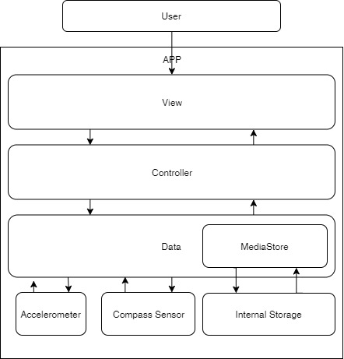

**Figure 3.1.1 System Architecture**

Figure 3.1.1 shows the architectural design of the software. It shows the communication of the software to the different libraries of the android software.

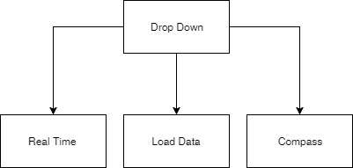

**Figure 3.1.2 System Architecture Views**

Figure 3.1.2 shows the different views of the android software and how it can be accessed by the user. The drop down module is responsible for selecting views for the user.

## Decomposition Description

### Use Case Diagrams

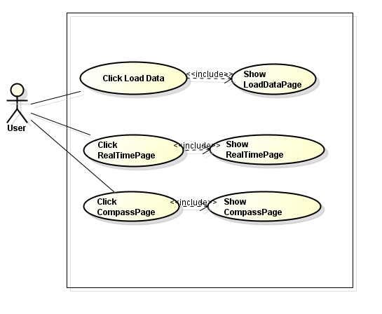

**Figure 3.2.1.1 Drop Down Module**

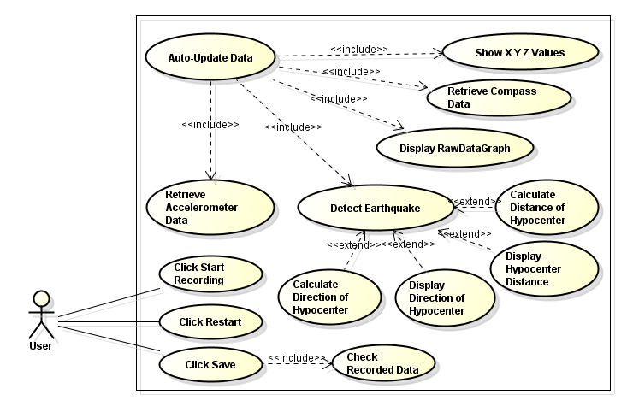

**Figure 3.2.1.2 Real Time Module**

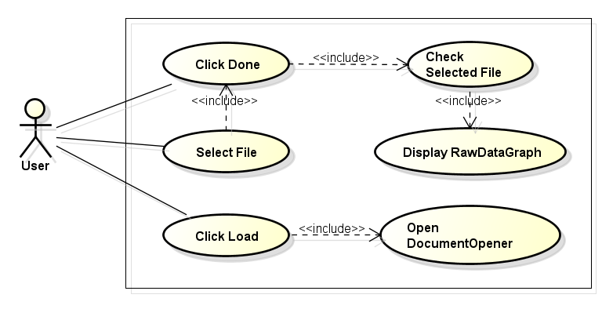

**Figure 3.2.1.3 Load Data Module**

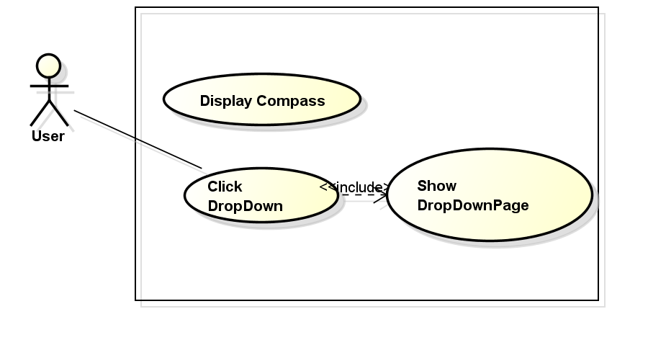

**Figure 3.2.1.4 Compass Module**

### Use Case Diagram Scenarios

Figure 3.2.1.1

**Title**: Drop Down

**Scenario**:

1. User may press “Load Data”.
2. User may press “Real Time Page”
3. User may press “Compass Page”

Figure 3.2.1.2

**Title**: Real Time Module

**Scenario**:

1. User may press “Load” button
2. User may select file
3. User can exit document selector feature
4. User may press “Done”

Figure 3.2.1.3

**Title**: Load Data Module

**Scenario**:

1. User can read the data from the accelerometer.
2. User may press “Start Recording”
3. User may press “Save”
4. User may press “Restart”

Figure 3.2.1.4

**Title**: Compass Module

**Scenario**:

1. User can turn the device

### Class Diagram

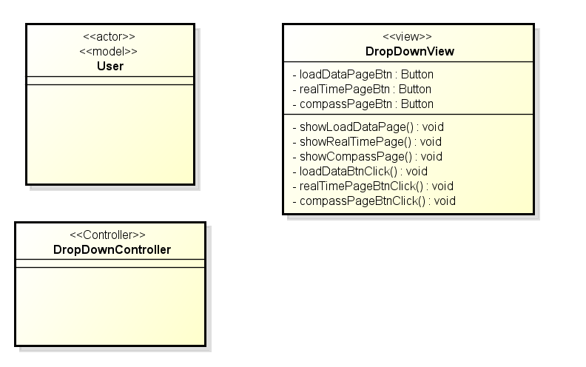

**Figure 3.2.3.1 Drop Down Class Diagram**

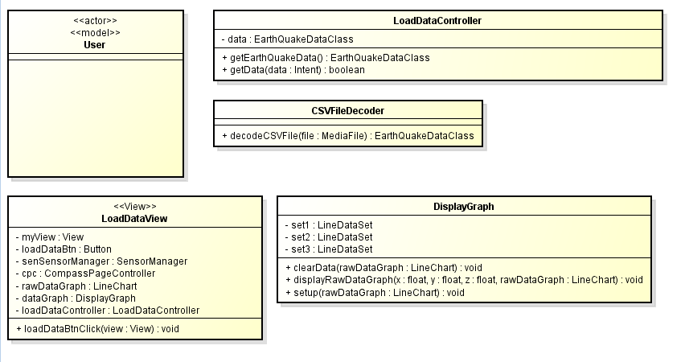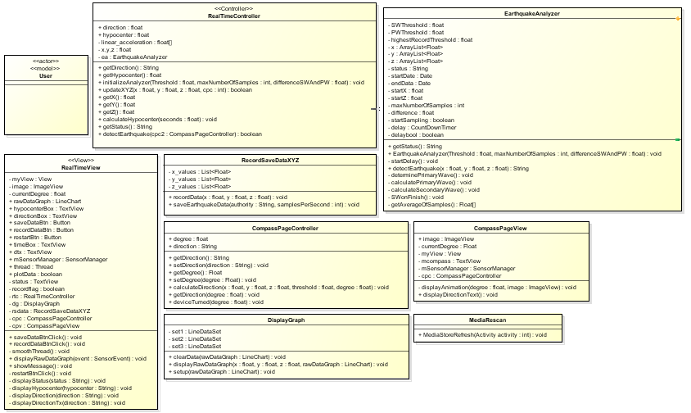**Figure 3.2.3.2 Real Time Class Diagram**

**Figure 3.2.3.3 Load Data Class Diagram**

## Design Rationale

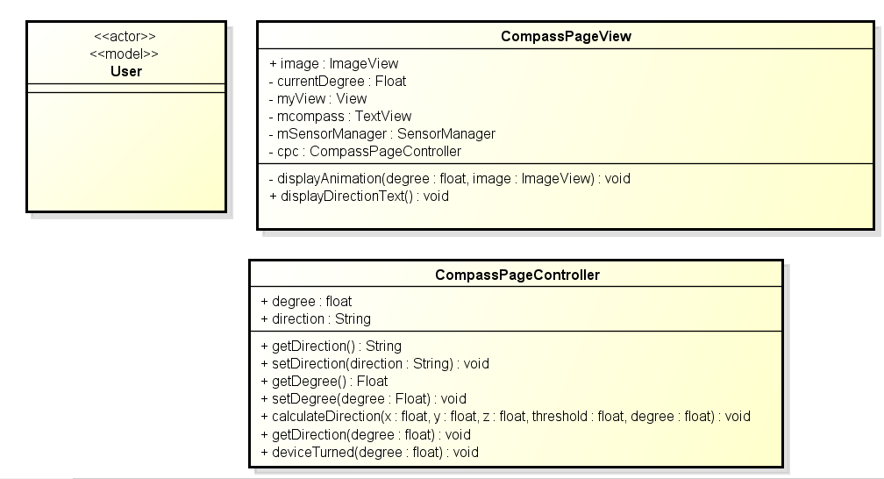

**Figure 3.2.3.4 Compass Class Diagram**

# Data Design

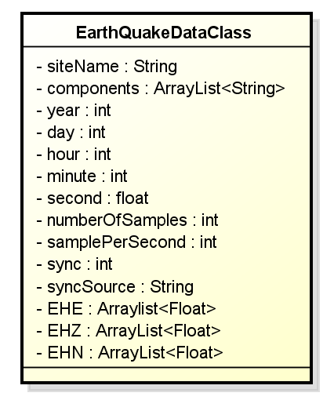

**Figure 4.1.1 Earthquake Data Class**

## Data Description

The sample above is an example of what are the data contains in the CSV file. The CSV file basically contains time information and accelerometer values. The important seismic data is contained in these three List<Float> values: EHE, EHZ, and EHN. The three represents x, y, and z values, respectively. Time information is based on the time the CSV file is generated.

## Data Dictionary

# Component Design

## Sequence Diagrams

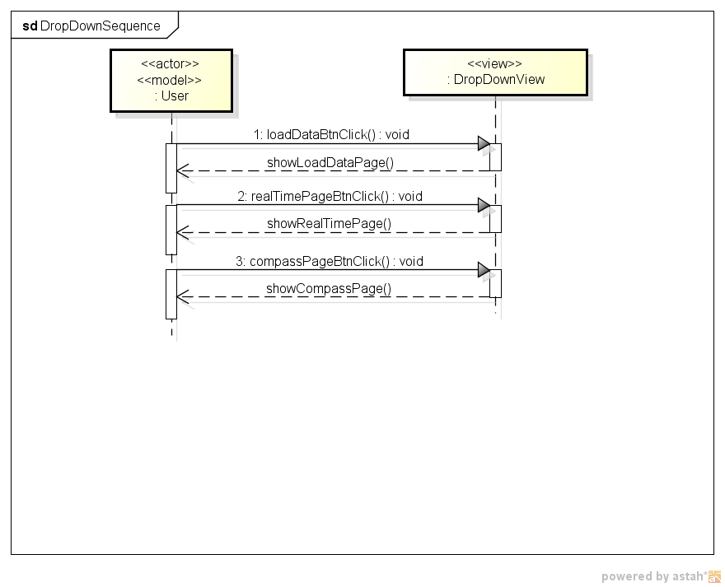

**Figure 5.1.1 Drop Down Sequence Diagram**

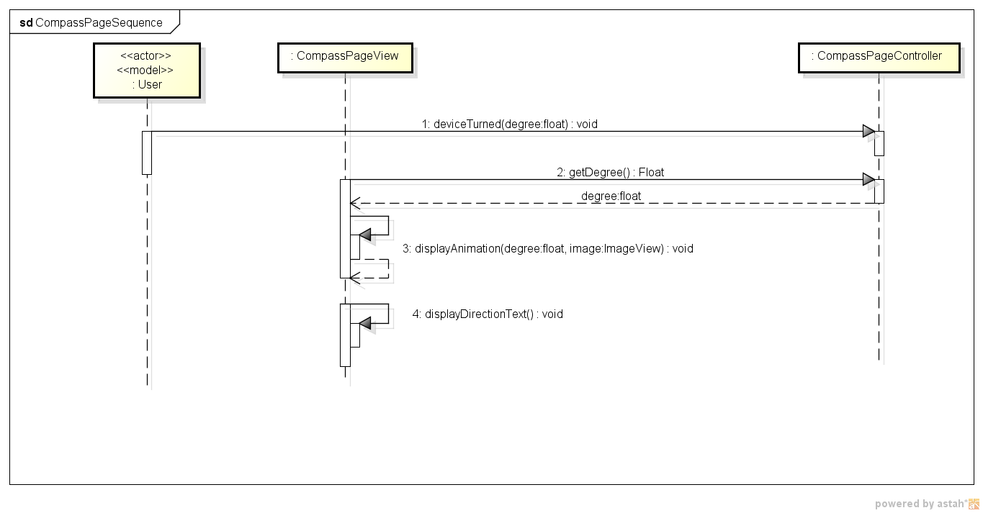

**Figure 5.1.2 Compass Sequence Diagram**

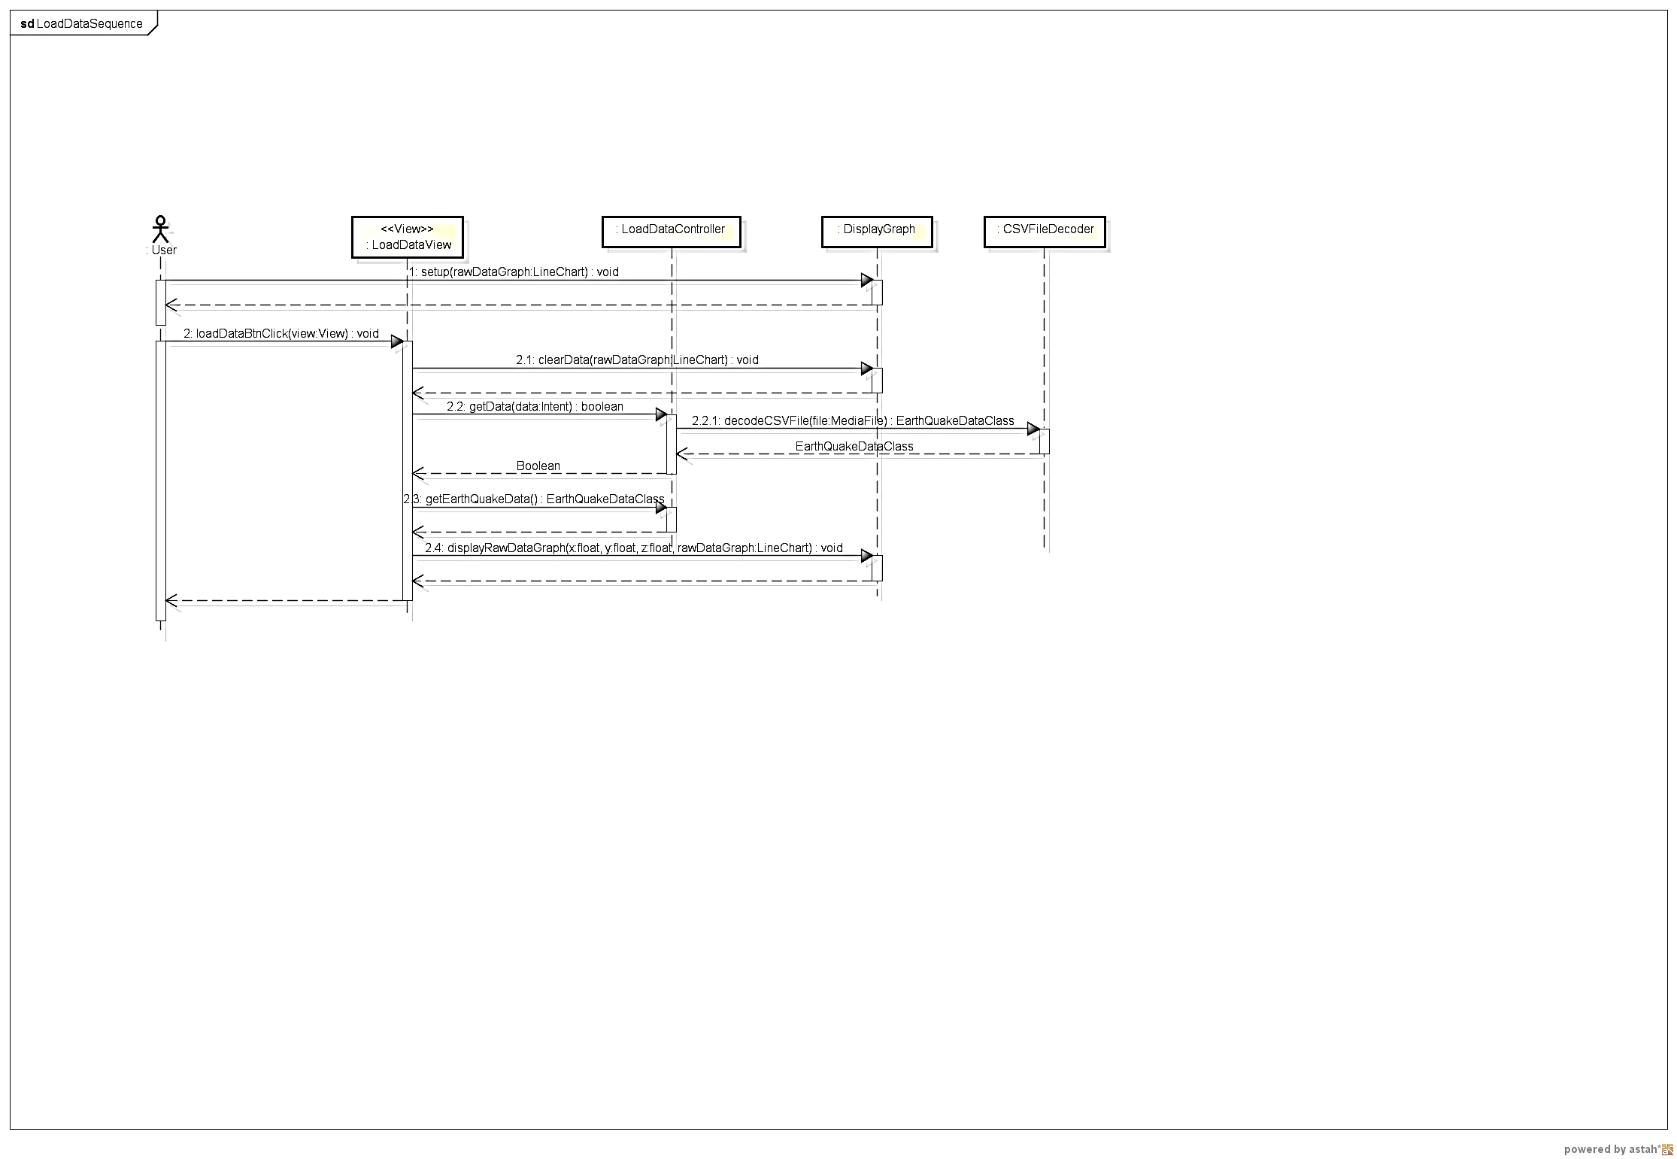

**Figure 5.1.3 Load Data Sequence Diagram**

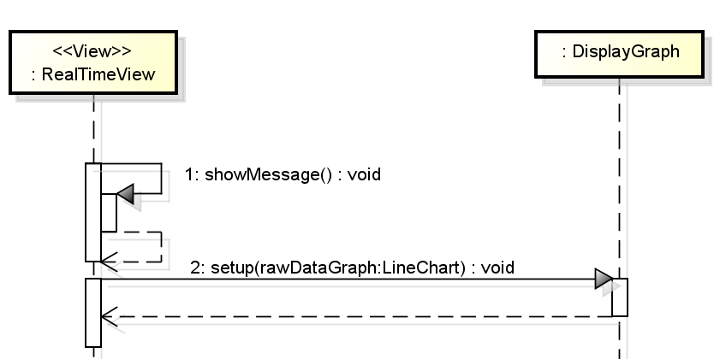

**Figure 5.1.4 Real Time Class Diagram – Initialization**

This sequence shows the initial algorithm of the real time sequence module upon selection from drop down.

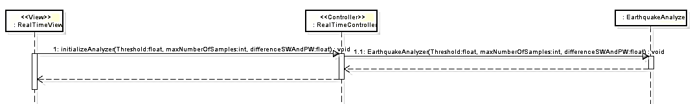

**Figure 5.1.5 Real Time Sequence Diagram – Continuation of Initialization**

This sequence shows the second part of the initialization of the real time module. This algorithm initializes the earthquake analyzer capability of the software.

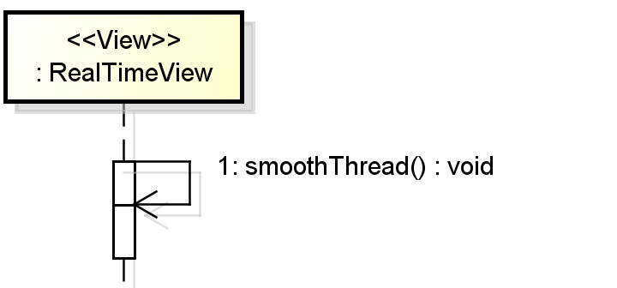

**Figure 5.1.6 Real Time Sequence Diagram – Smooth Thread**

This thread smoothens the flow of data of the flow chart. This will ensure fluid movement of update of the line chart in the real time module.

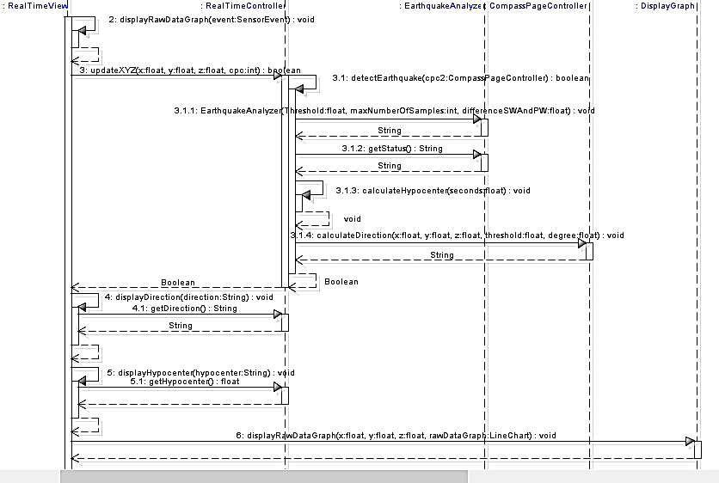

**Figure 5.1.7 Real Time Sequence Diagram – Line Chart Update and Earthquake Detection**

This sequence shows how does line chart is constantly updated while detecting earthquake on runtime. This also shows when will the software displays direction and distance of the hypocenter.

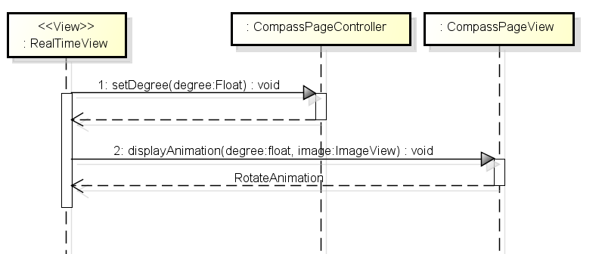

**Figure 5.1.8 Real Time Sequence Diagram – Compass Animation**

This sequence shows the algorithm of the compass animation.

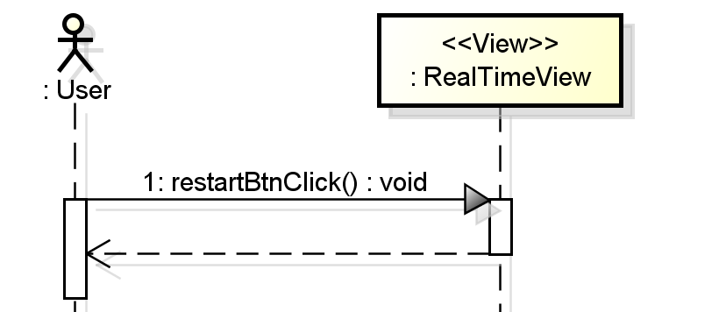

**Figure 5.1.9 Real Time Sequence Diagram – Restart Button**

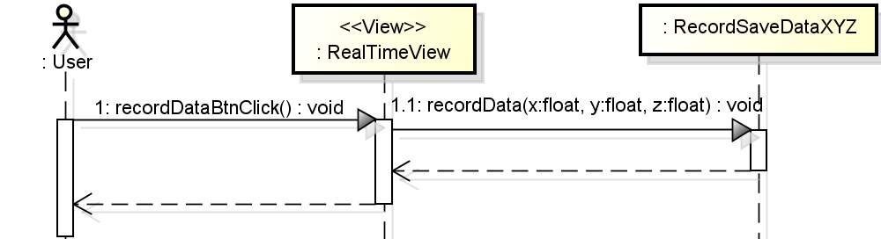

**Figure 5.1.10 Real Time Sequence Diagram – Record Button**

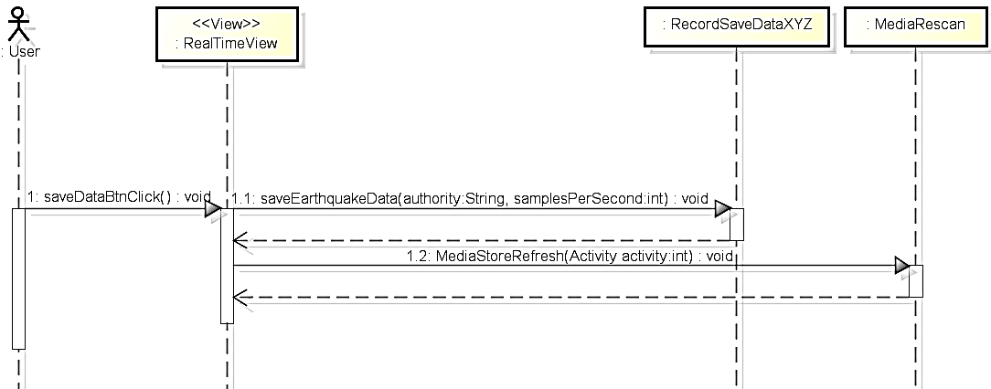

**Figure 5.1.11 Real Time Sequence Diagram – Save Data Button**

## Overview of User Interface

The following data will show the all the user interface of the Earthquake Analyzer Application and also describe the function of the clickable and non-clickable object in each of the user interface.

# Human Interface Design

## Screen Images

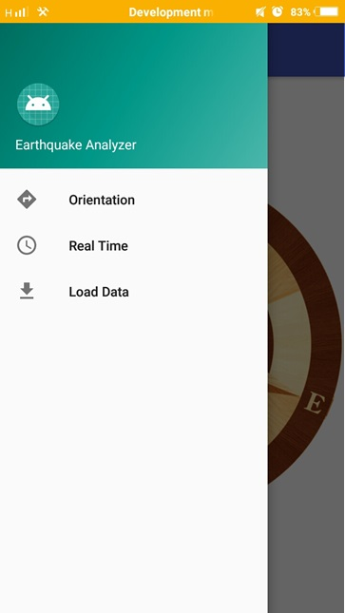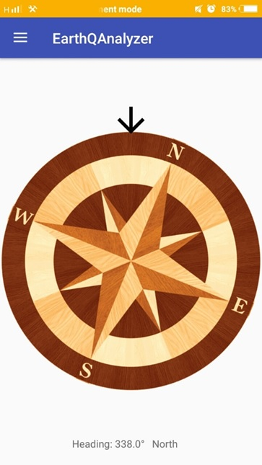:

*Figure 6.1.1: Earthquake Analyzer Orientation Screen*

*Figure 6.1.2: Drop Down Menu*

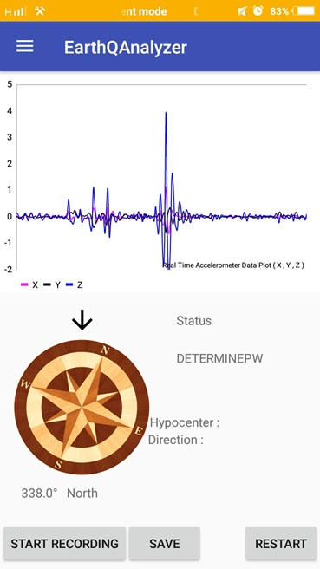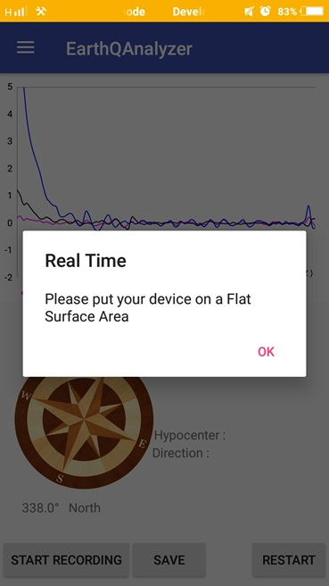

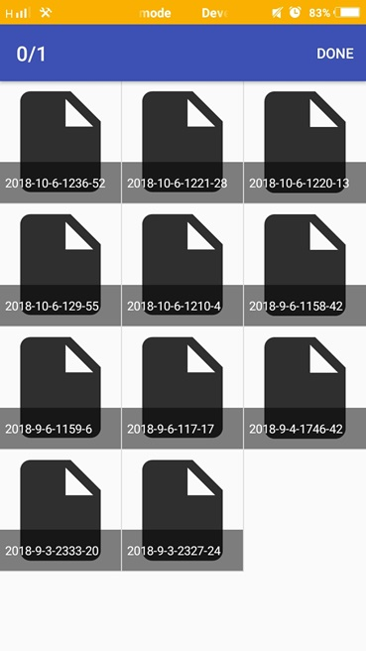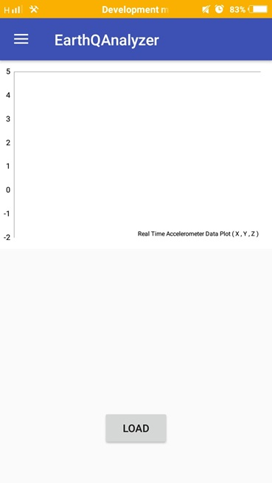

*Figure 6.1.3b: Real Time Screen*

*Figure 6.1.3a: Real Time Screen Pop Up Message*

*6.1.5a: Document Opener*

*6.1.4a: Load Data Screen*

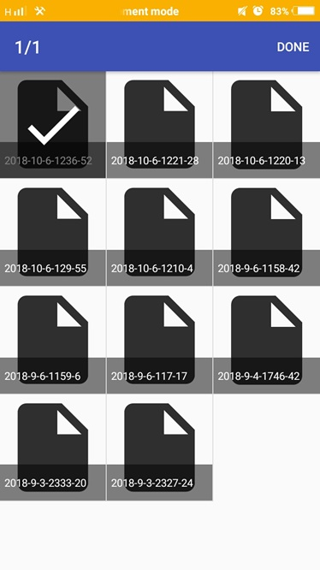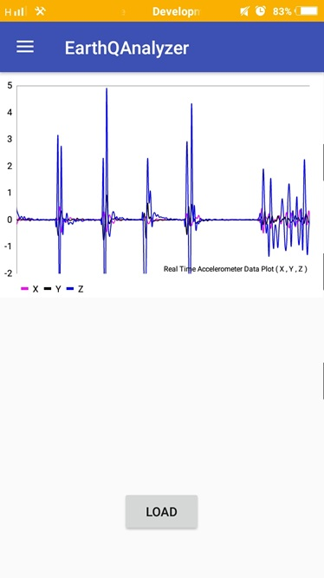

*5.1.04b: Data Shown*

*5.1.05b: Data Selected*

## Screen Objects and Actions

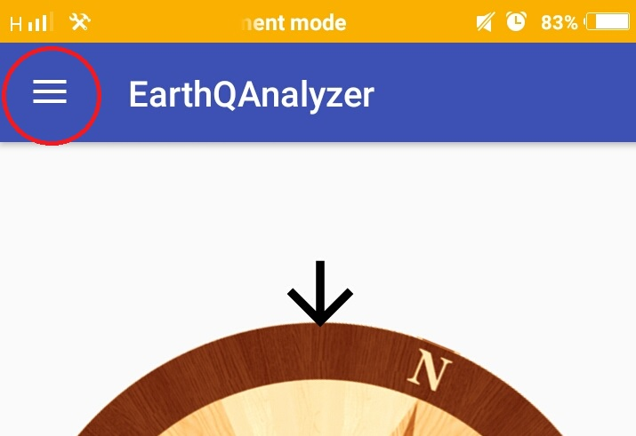Figure 6.3.01 show the Drop-Down Button. This button will open the Drop-Down Menu on the left side of the screen of the application.

*Figure 6.3.01: Drop Down Button*

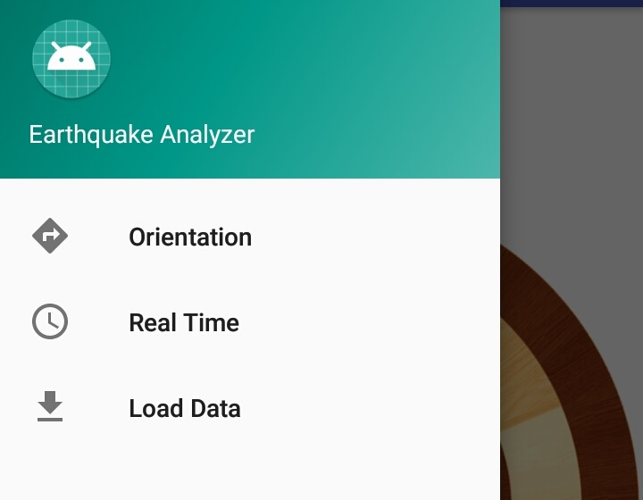Figure 6.3.02 shows the three buttons in the Drop-Down Menu. These buttons, if pressed, will redirect the user to the three major screens of the application. The Orientation button will redirect the user to the Orientation Screen where the Compass feature is located. The Real Time button will redirect the user to the Real Time Screen where the Real time reading and graphing of the output of the accelerometer of the phone is found. And lastly, the Load Data button will redirect the user to the Load Data Screen where the saved data from the Real Time page will be found and be loaded.

*Figure 6.3.02: Drop Down Menu Buttons*

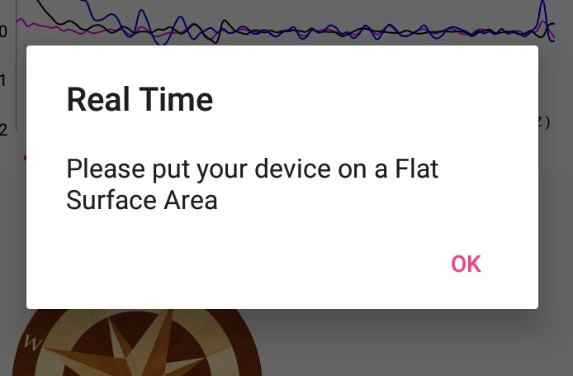

Figure 6.3.03 shows the pop up message when the Real Time Screen is opened. It Prompts the user to put the device into a Flat surface or stable surface to reduce the noise in the output of the accelerometer.

*Figure 6.3.03: Real Time Pop up Message*

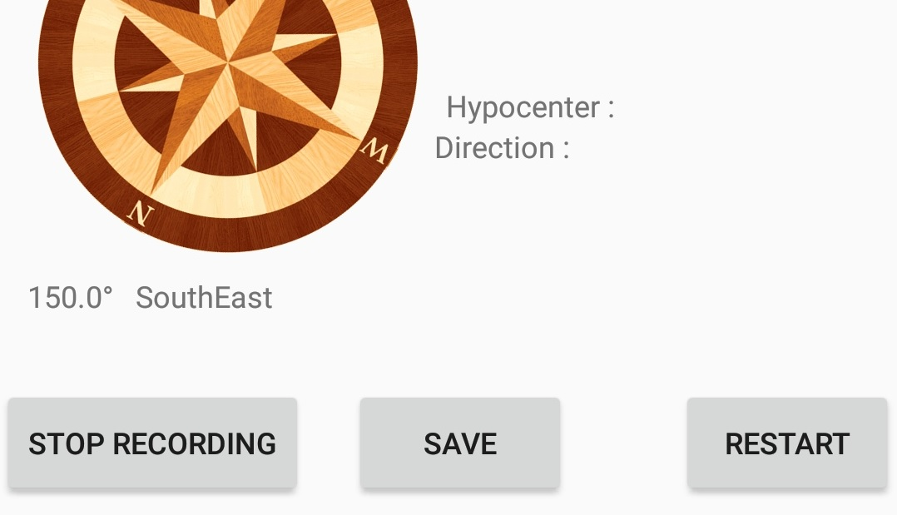Figure 6.3.03 shows all the buttons found in the Real Time Screen. The Start Recording Button will, as its name says, start the recording of data outputs of the accelerometer. Then the button name will change into stop recording. The Stop Recoding Button will stop recording the data. The Save button will save the data recorded. The restart button will restart the output found below the Status Text Box in the Real Time.

*Figure 6.3.04: Real Time Screen Objects*

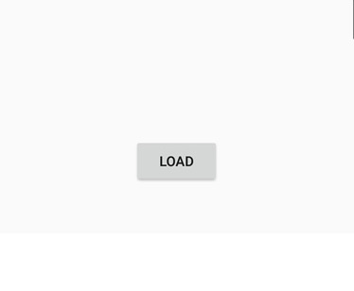Figure 6.3.05 shows the Load Button. It is found in the Load Data Screen. It opens the document opener to load the saved data from the accelerometer.

*Figure 6.3.05: Load Button*

# Requirement Matrix

# Appendices